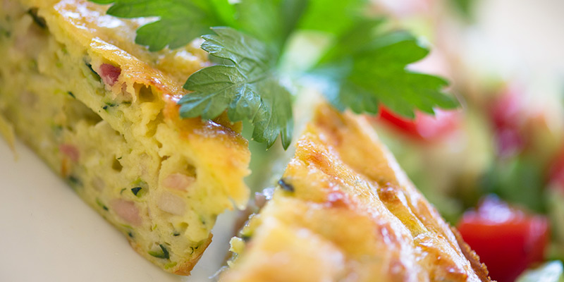

ZUCCHINI SLICE

750g zucchini

2 x large Onions

2 cups grated cheese

2 cups self-raising flour

1 cup vegetable oil

1 cup corn kernels

10 Eggs

salt & pepper

Grate unpeeled zucchini (squeeze all the juice out in a colander)

Finely chop onions, combine zucchini, onion, cheese, sifted flour, drained corn, oil and lightly beaten eggs, season with salt and pepper.

Grease two baking dishes and bake in a moderate over for 30minutes or until cooked.

